Computer Architecture, CPU, Cores, RAM & Cache

1. Introduction
Computer architecture is the engineering discipline concerned with the design, organization, and integration of computer system components. It defines the functional behaviour, performance characteristics, and structural implementation of hardware units such as:
- Central Processing Unit (CPU)
- Processing Cores
- Random Access Memory (RAM)
- Cache Hierarchy
These components collectively determine system throughput, latency characteristics, and computational efficiency.

2. Central Processing Unit (CPU)
The CPU is the primary computational unit responsible for executing machine instructions defined by the system’s Instruction Set Architecture (ISA). It performs arithmetic, logical, control, and I/O coordination tasks.
2.1 Internal Architecture
A modern CPU typically contains:
a) Arithmetic Logic Unit (ALU)
Executes integer-based arithmetic and logical operations.
b) Floating Point Unit (FPU)
Handles floating-point calculations required in graphics, scientific computation, and ML workloads.
c) Control Unit (CU)
Decodes instructions, generates control signals, and orchestrates data flow between registers, memory, and peripherals.
d) Registers
Small, ultra-low latency storage elements directly accessible by the CPU pipeline.
Common types: Program Counter (PC), Instruction Register (IR), General Purpose Registers, Status Flags.
2.2 Instruction Pipeline
Modern CPUs implement pipelining to enhance instruction throughput. Pipeline stages include:
- Fetch
- Decode
- Execute
- Memory Access
- Write Back
Advanced CPUs also support superscalar execution, branch prediction, and out-of-order execution to reduce stalls and improve performance.

3. CPU Cores
A core is an independent processing engine capable of executing its own instruction stream. Multi-core CPUs integrate several cores on a single chip to increase parallelism.
3.1 Types of Core Architectures
a) Single-Core
Executes one instruction thread at a time; low parallel capability.
b) Multi-Core (Dual, Quad, Octa-Core, etc.)
Enables true parallel processing of multiple threads, improving system throughput.
c) Simultaneous Multithreading (SMT) / Hyper-Threading
Allows a single core to execute multiple threads logically, improving utilization of execution units.
3.2 Engineering Benefits
- Improved instruction-level parallelism (ILP)
- Better multithreaded performance
- Lower power consumption per instruction compared to frequency scaling
- Enhanced support for engineering applications (MATLAB, CAD, ML training, simulations)

4. Random Access Memory (RAM)
RAM is a high-speed, volatile semiconductor memory that stores data and instructions required by the CPU during program execution.
4.1 Characteristics
- Volatile: Data is lost when power is removed
- High bandwidth and low latency compared to secondary storage
- Organized as DRAM (Dynamic RAM) in most consumer systems
4.2 DRAM Working Principle
DRAM stores bits using charge in capacitors, requiring periodic refresh cycles. It is slower than SRAM but more cost-efficient for large capacities.
4.3 RAM Performance Metrics
- Capacity (8 GB, 16 GB, etc.)
- Frequency / Data Rate (e.g., DDR4 3200 MT/s)
- CAS Latency
- Memory Channel Architecture (Single/Dual/Quad Channel)
4.4 Engineering Use Cases
- Large dataset handling
- Compiler and IDE performance
- Simulation workloads
- Multitasking during software development

5. Cache Memory
Cache memory is a high-speed, low-latency storage layer positioned between the CPU and RAM. It is implemented using SRAM due to its superior speed and does not require refresh cycles.
5.1 Cache Hierarchy Levels
L1 Cache (Level 1)
- Closest to the CPU core
- Split into L1 Instruction Cache & L1 Data Cache
- Extremely fast but small (32–128 KB)
L2 Cache
- Larger (256 KB–1 MB)
- Moderate latency
- May be private to each core or shared
L3 Cache
- Shared across all cores
- Large size (4–64 MB)
- Helps reduce inter-core communication delay
5.2 Importance of Cache
- Decreases average memory access time
- Reduces CPU stalls
- Enhances performance of tight loops and repeated operations
- Critical for engineering workloads such as ML inference, real-time systems, and graphics rendering

6. Memory Access Hierarchy
Computer systems use a hierarchical memory model for optimal performance:
- Registers (fastest, smallest)
- L1 Cache
- L2 Cache
- L3 Cache
- RAM
- Secondary Storage (SSD/HDD)
The performance of a system depends heavily on how efficiently this hierarchy is utilized by the processor.
1. Computer architecture
Computer architecture is the design of the internal structure, behaviour, and organization of a computer system, describing how its major components such as the CPU, memory, input/output devices, and data pathways work together to execute instructions efficiently. It defines how hardware and software interact, how data is processed, and how different units communicate through buses and control signals. A key focus of computer architecture is optimizing performance through techniques like pipelining, parallel processing, multi-core CPUs, and hierarchical memory systems including RAM and cache. Overall, computer architecture determines how fast, efficient, and reliable a computer system can be, forming the foundation for modern computing, embedded systems, and high-performance applications.
2. CPU (Central Processing Unit)
The CPU is the main processing unit of a computer and is often referred to as its brain because it performs all the important operations needed to run programs. It executes instructions such as calculations, decision-making, and controlling the flow of data between different components. The CPU contains several internal units such as the Arithmetic Logic Unit (ALU), which performs mathematical and logical operations, and the Control Unit (CU), which interprets and manages the execution of instructions. Registers inside the CPU provide very fast temporary storage for data during processing. Overall, the speed and efficiency of the CPU largely determine how fast the computer can perform tasks.

3. Cores
A core is an independent processing unit inside the CPU, and modern processors contain multiple cores to increase performance. Each core can execute its own instructions, which allows the computer to perform several tasks simultaneously. For example, a dual-core CPU can handle two operations at once, while a quad-core or octa-core processor can manage even more. Multi-core processors are especially useful for multitasking, gaming, video editing, machine learning, and other operations that require parallel processing. Some CPUs also use technologies like Hyper-Threading that allow a single core to act like two virtual cores, increasing efficiency further. More cores generally mean smoother performance and better handling of heavy workloads.

4. RAM (Random Access Memory)
RAM is the computer’s short-term memory, where it temporarily stores data and instructions needed by the CPU. It is much faster than long-term storage devices like SSDs or HDDs, which allows programs to run quickly and efficiently. RAM is volatile, meaning its data is erased when the computer is turned off. When you open applications, load files, or run software, they are placed into RAM so the CPU can access them instantly. More RAM allows a computer to run multiple applications at the same time without slowing down. It plays a major role in overall system performance, especially in scenarios like gaming, software development, and data processing.

5. Cache Memory
Cache memory is a very fast type of memory located inside or near the CPU, designed to reduce the time the CPU spends waiting for data from RAM. Since the CPU operates extremely fast, even small delays in fetching data from RAM can slow it down. Cache stores copies of frequently accessed data and instructions so the CPU can retrieve them almost instantly. It is organized into levels—L1, L2, and L3—each with different sizes and speeds. L1 is the smallest but fastest, while L3 is larger but slower. When the CPU finds the required data in the cache (called a cache hit), performance increases significantly. Cache memory plays a vital role in optimizing computer speed and reducing processing time.

Types of Computer Networks
Computer networks are classified based on their size, geographical coverage, architecture, and purpose. Below are the major types of networks used in modern computing.
1. PAN (Personal Area Network)
A PAN is the smallest type of network that covers a very small area around a person, typically within a range of a few meters.
Examples
- Connecting a smartphone to a laptop using Bluetooth
- Smartwatches connected to phones
- Wireless headphones
Key Features
- Very short range
- Low cost
- Low power consumption
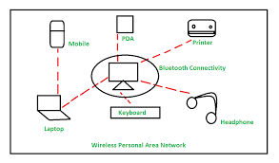
2. LAN (Local Area Network)
A LAN covers a small geographical area such as a home, office, school, or building. It is commonly used for internal communication and file sharing.
Examples
- Wi-Fi in homes
- Computer labs
- Office networks
Key Features
- High speed (100 Mbps – 10 Gbps)
- Controlled by a single organization
- Uses Ethernet or Wi-Fi
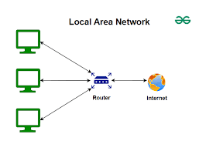
3. WLAN (Wireless Local Area Network)
A wireless version of LAN that uses radio waves to connect devices without cables.
Examples
- Home Wi-Fi routers
- Wi-Fi hotspots in cafes or airports
Key Features
- Easy installation
- Supports mobile devices
- Uses standards like IEEE 802.11
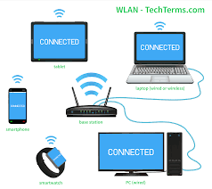
4. MAN (Metropolitan Area Network)
A MAN covers a larger area than a LAN but smaller than a WAN, typically a city or large campus.
Examples
- City-wide Wi-Fi
- University campus networks
- Cable TV networks
Key Features
- Medium-range coverage
- Higher speed than WAN
- Often managed by government or telecom providers
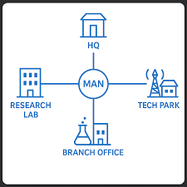
5. WAN (Wide Area Network)
WAN covers a large geographical area such as countries or continents. It connects multiple LANs and MANs together.
Examples
- The Internet (largest WAN)
- Banking networks across multiple cities
- Global company networks
Key Features
- Long-distance communication
- Lower speed compared to LAN
- Uses technologies like satellite links, fibre optics
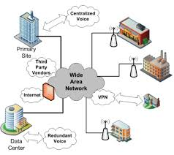
6. SAN (Storage Area Network)
A specialized high-speed network that connects servers to storage devices.
Examples
- Data centres
- Cloud storage infrastructures
Key Features
- Very high speed
- Dedicated for data storage
- Highly reliable
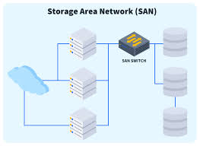
7. CAN (Campus Area Network)
A CAN connects multiple LANs within a campus-like environment, such as a university or corporate office park.
Examples
- University campus network
- Business campus with multiple buildings
Key Features
- Larger than LAN
- High bandwidth
- Controlled by a single organization
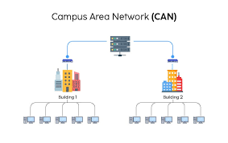
8. VPN (Virtual Private Network)
A secure private network created over the public Internet using encryption.
Examples
- Employees accessing company network from home
- Secure browsing on public Wi-Fi
Key Features
- Ensures privacy
- Protects data from hackers
- Provides remote access
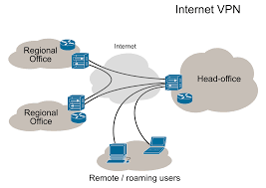

1. What is IPv4 vs IPv6?
IPv4 (Internet Protocol Version 4)
- Uses a 32-bit address.
- Total possible addresses: 4.3 billion
- Written in dot-decimal format (e.g., 192.168.1.1)
- Most widely used, but running out of addresses.
- Supports NAT due to limited IP availability.
IPv6 (Internet Protocol Version 6)
- Uses a 128-bit address.
- Total possible addresses: 3.4 × 10³⁸ (almost unlimited)
- Written in hexadecimal (e.g., 2001:0db8:85a3::8a2e:0370:7334)
- Eliminates address exhaustion.
- Built-in security features (IPsec).
- No need for NAT because of huge address space.
2. What is a Subnet?
A subnet (subnetwork) is a smaller, logical division of a larger network.
Why use a Subnet?
- Improves network performance
- Provides better security
- Reduces broadcast traffic
- Helps organize networks (e.g., separating staff and students)
Example
Network: 192.168.1.0/24
This can be divided into smaller subnets like:
- 192.168.1.0/26 (64 hosts)
- 192.168.1.64/26
- 192.168.1.128/26
- 192.168.1.192/26
Subnet Mask
A number that identifies the network and host portion of an IP address.
Example:
- Subnet mask: 255.255.255.0
- Meaning: first 3 octets = network, last octet = hosts

3. What is Network Address Translation (NAT)?
NAT is a technique that allows multiple devices on a private network to share one public IP address when accessing the Internet.
Why NAT is used
- Saves public IP addresses (important in IPv4)
- Provides internal network security
- Hides private devices from the outside world
How NAT Works
When a device in a private network (e.g., 192.168.1.5) sends data to the Internet:
- Router replaces its private IP with the public IP.
- The Internet sees only the router’s public IP.
- Responses go back to the router.
- Router sends data to the correct internal device.
Types of NAT
- Static NAT – one private IP ↔ one public IP
- Dynamic NAT – private IP ↔ pool of public IPs
- PAT (Port Address Translation) – many devices share a single public IP (most common)

